
Fonte School

Name: ____________________________________ Teacher : Elaine Vieira
Today is : __________________________________ Level: _________________
TRABALHO - INGLÊS - 6 ⁰Ano - 4⁰ Bimestre

1) Complete with ´ ou ´s:
a) Peter __________ car is in the garage.
b) Mr. John __________secretary is outside.
c) They sell ladies __________ hats in this store.
d) The doctor __________ wife is very gentle.
e) My friends __________sisters are beautiful.
f) We love grandma __________ cakes.
g) I don´t like boys __________shoes

2) Use the genitive case: Coloque no caso genitivo. Faça como o exemplo:
The dresses of the girls. The girls´dresses.
a) The tail of the dog. _________________________________________
b) The house of the men. _____________________________________
c) The car of John. ___________________________________________
d) The idea of Mary. __________________________________________

3 ) Complete the sentences. Use Present Simple affirmative:

a. My brother _________ (play) football.

b. We _________ (eat) hamburguers.

c. I _________ (study) French.

d. My friends _________ (listen) to jazz.

e. My mom __________ (like) classical music

4 - Turn the sentences below into negative form:
( Passe para a forma NEGATIVA ):

a. I eat pizza.

______________________________________

b. My brother studies German.

______________________________________

c. We play computer games.

______________________________________

d. Harry likes sport.

______________________________________

e. They drink water.

______________________________________

5) Circle the correct verb form:

a. We go/goes to school by bus.

b. My teacher speak/speaks Italian and Japanese.

c. We don’t/doesn’t do P.E in the classroom.

d. My friends don’t like/likes art.

e. My mother teach/teaches in a primary school.

f. I don’t copy/copies their homework.

6 ) Write the 3rd Person form ( Simple Present). Remember the spelling rules!

eat _________ do ________

study ________ watch ________

drink ________ read ________

make ________ learn ________

clean __________ play _________

7) Write the correct word to complete the sentences:

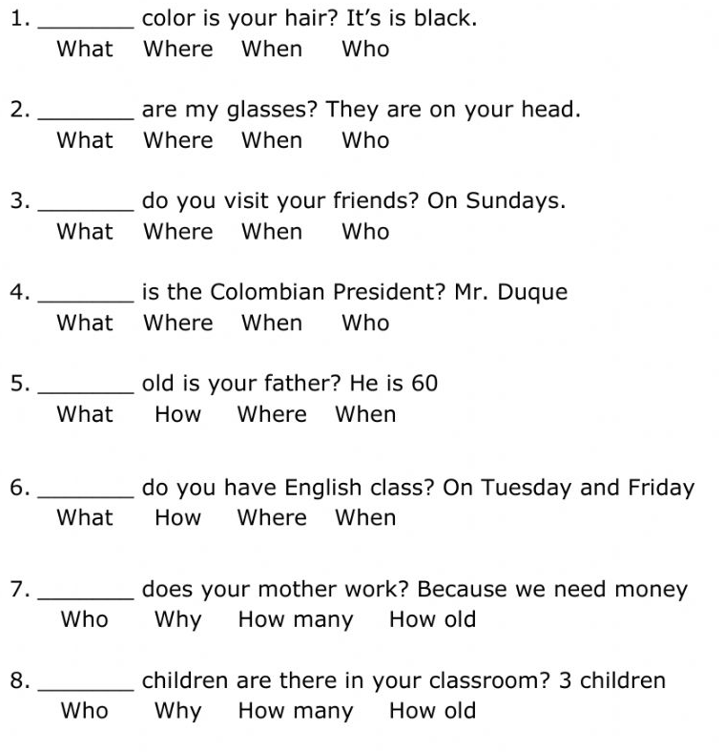

8 )Look at the Infographic. Answer the questions in Portuguese:
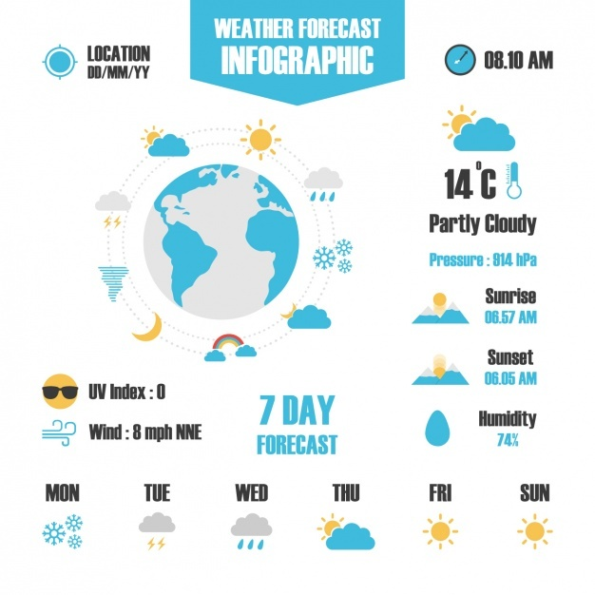
A. O que informa o infográfico acima?

B. Explique as abreviações :

Mon Tue Wed Thu Fri Sun

C. O que significa wind ?

D. O que informam as figuras neste infográfico?

9) Write interrogative sentences. Use do/does and the verbs in parenthesis:

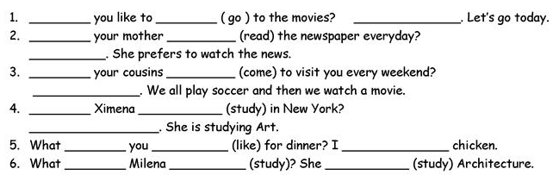

10) Put the words in the correct order:

