Lista de exercícios – Rec - 7º ano

Dear student!
Esta lista de exercícios traz exercícios de fixação. Você deve copiar a lista no seu caderno, NÃO SERÃO ACEITAS LISTAS NO WORD, PDF, ETC, responder e me enviar as fotos pela unimestre ou whatsapp. Entregar o original para o André até as 12hs do dia 07/12. A escrita nos ajuda a memorizar vocabulário, aprimorar nossa escrita e ajustar nosso raciocínio ao idioma. Ao final dos exercícios, elabore o vocabulário desta lista, escrevendo todas as palavras que você não conhecia e anotando seus respectivos significados em inglês. Prestar atenção à data de entrega e ao cuidado com o seu trabalho! Qualquer dúvida estou à disposição!
Teacher Elieth

Past continuous:
- Look at the pictures and answer the questions below, then turn these sentences into the negative form
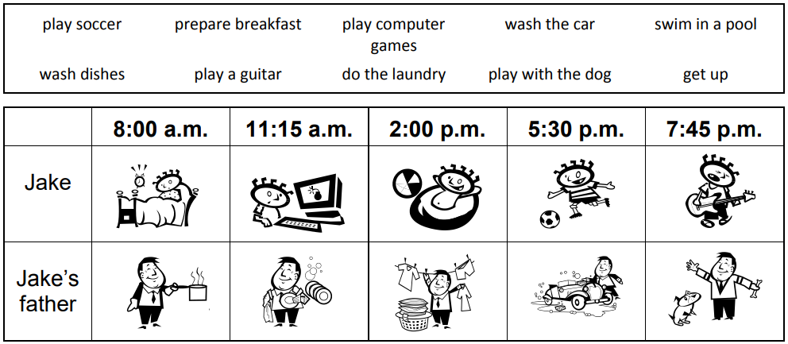

1. What was Jake doing at 8:00 a.m.?
____________________________________________________________
2. What was Jake’s father doing at 5:30 p.m.?
_______________________________________________________________
3. What was Jake’s father doing at 11:15 a.m.?
_______________________________________________________________
4. What was Jake doing at 2:00 p.m.?
_______________________________________________________________
5. What was Jake’s father doing at 8:00 a.m.?
_______________________________________________________________
6. What was Jake doing at 11:15 a.m.?
_______________________________________________________________
7. What was Jake’s father doing at 2:00 p.m.?
_______________________________________________________________
8. What was Jake doing at 7:45 p.m.? _______________________________________________________________
9. What was Jake doing at 5:30 p.m.? _______________________________________________________________
10. What was Jake’s father doing at 7:45 p.m.?
_______________________________________________________________

- Fill in the blanks below to complete the sentences. Use the correct form of verb to be to make sentences in the past continuous:
1. A: ___________ they watching TV at midnight?
B: No, they ___________.
2. We ___________ eating lunch in the cafeteria at noon.
3. A: ___________ you talking on the phone a few minutes ago?
B: No, I __________.
4. I ___________ walking home when I saw the car accident.
5. My classmate and I ___________ studying together at the library.
6. While he ___________ cleaning the house, we ___________ cooking. 7. A: What ___________ you doing at one o’clock?
B: I ___________ sleeping.
8. The car engine ___________ working, so I had to fix it.
9. A: ___________ you listening to the teacher?
B: Yes, I ___________.
10. At seven o’clock, Mr. Smith ___________ robbing the bank.
11. Steven ___________ doing his homework, he was playing with his friends.
12. It ___________ raining last night, so I took my umbrella.
13. Anne ___________ studying in London last year.
14. I ___________ working as a teacher when I first met your mother. 15. We ___________ swimming while you ___________ playing volleyball.

Could:
- Complete with could or couldn’t:
1. When I was young, I ____________ play the guitar: it was too difficult for me!
2. Her grandmother was bilingual: she ____________speak both English and Spanish.
3. Yesterday, Peter ____________do that exercise alone. So, he called me for help.
4. In 1950, people ____________ use mobile phones.
5. When his mother was young, she ____________skate but she can't do it any longer.
6. We ____________ open the door: it was locked from the inside!
7. In 1900, people ____________watch TV.
8. Mary's grandfather ____________ play chess and he was the best!
9. In 1945, people ____________ play video games.
10. But they ____________play chess!

