Lista de exercícios – Rec – 3º médio

Dear student!
Esta lista de exercícios traz exercícios de fixação. Você deve copiar os exercícios no seu caderno para
realizá-los, NÃO SERÃO ACEITAS LISTAS NO WORD, PDF, ETC, responder e me enviar as fotos pela unimestre ou whatsapp. Entregar o original para o André até as 12hs do dia 07/12. A escrita nos ajuda a memorizar vocabulário, aprimorar nossa escrita e ajustar nosso raciocínio ao idioma. Ao final dos exercícios, elabore o vocabulário desta lista, escrevendo todas as palavras que você não conhecia e anotando seus respectivos significados em inglês. Prestar atenção à data de entrega e ao cuidado com o seu trabalho! Qualquer dúvida estou à disposição!
Teacher Elieth

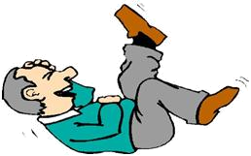
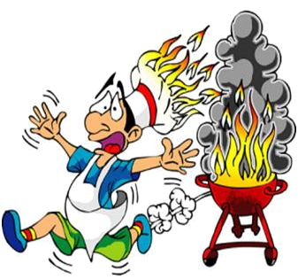
A Terrific Cook

Do you see how slim I am? It’s not on purpose and it’s not my nature either; there’s a good reason for me keeping in shape: Mom. She’s a disaster in the kitchen, and besides being unable to fry an egg properly, she always causes accidents. I can’t keep track of all the times the kitchen was on fire (4? 5?) because of something weird she decided to do, despite of our advice to keep out of the kitchen – especially the stove.

She doesn’t pay attention to our advice and we have to eat what she prepares – or at least we eat what we can – so we live constantly on an undesired diet.
The last time she tried to prepare roast beef the result was a burning kitchen; Dad could barely save the family and extinguish the fire. When she goes to the kitchen we start fearing for our lives (and stomachs) and thinking of a sickness we’ll fake in order to avoid the “result”.
Despite the bad cook we have at home, our house is always full of guests for lunch and dinner. I suspect they come just to have fun watching the disasters. And – of course – they want to be the first to tell our friends what her latest calamity was like.

Mark true (T) or false (F) according to the text. You have to explain orally when it’s false:
The girl’s mother is a terrific cook. ( )
The girl’s mom tends to cause accidents in the kitchen. ( )
The girl’s mother knows how to cook. ( )
The girl’s mom gave up cooking. ( )
The family asks the woman to stop cooking. ( )
The woman keeps cooking and doesn’t listen to her family. ( )
They have to eat what she cooks. ( )
She set fire in the kitchen more than once. ( )
They have guests because they appreciate her food. ( )
The girl used two strong words to refer to her mom’s accidents in the kitchen. What are they? Why do you think she has chosen them?
__________________________________________________________________
Who is the “terrific cook” mentioned in the title?
______________________________________________________________________
Is she a “terrific” cook? What adjectives would you use to describe her abilities in the kitchen?
______________________________________________________________________
Do you know someone who’s a terrible cook? (If affirmative) What kind of situations does this person cause?
______________________________________________________________________
Who suffers the most with the consequences of bad cooking: the cook or his / her guests / family? Explain.
______________________________________________________________________

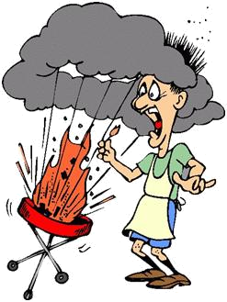
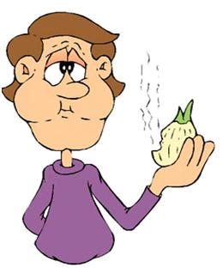
What’s the most important quality you need to be a good cook?
________________________________________________
Do you think that learning how to cook is easy or difficult? Why?
________________________________________________
Are you a good cook? What’s your specialty?
________________________________________________
Would go to a friend’s house for dinner if you knew the cook is terrible? Why (not)?
________________________________________________
Do you think the story is real? Why (not)? ______________________________________
______________________________________________________________________
Do you think a bad cook – more than a healthy diet – can make people keep in shape? Why (not)? ________________________________________________________________
______________________________________________________________________
Do you think the text is ironic? Why do you think so? ______________________________
______________________________________________________________________
Choose another title for the story: ____________________________________________
Mark the alternative you think that fits better:
1. The girl’s mother is a __ cook.
a) terrificb) terriblec) creative
2. The girl is __ because of her mother’s cooking.
a) fatb) skinnyc) thin
3. Because of the cook, the family is always in a(n) __ diet.
a) endlessb) healthyc) low-calorie
4. There are tons of __ for dinner at the girl’s house.
a) helpersb) curious peoplec) guests
5. The guests want to __.
a) have fun and gossipb) eatc) go on a diet with them
Read the sentence taken from the story: “I suspect they come just to have fun watching the disasters.” After expressions like: have fun, have a (great, good, etc.) time, have trouble, have difficulty the verb that follows comes in the –ing form. Complete the sentences below:
I had lots of difficulties _____________ to find your house, Sue. [to find]
We have had fun ______________ in the backyard. [to play]
Mom told us she had a great time __________________ around the world. [to travel]
Ernest will have trouble _________________ why he got a C on the test. [to explain]
The girls would have fun ____________________ this movie if they were here. [to watch]

